**TECHNICAL REPORT ON THE ANALYSIS OF CALVARY COLLEGE STUDENT'S MENTAL HEALTH AND COPING MECHANISM**

## **1. Outline**

This report presents a structured analysis of student mental health, academic performance, stress coping methods, and lifestyle habits such as physical exercise and social media usage. Data was processed and analyzed using Microsoft Excel to extract actionable insights.

### **Sections:**

* Introduction
* Story of Data
* Data Splitting and Preprocessing
* Pre-Analysis
* In-Analysis
* Post-Analysis and Insights
* Data Visualizations & Charts
* Recommendations and Observations
* Conclusion

**2. Introduction**

### **Objective of the Project:**

To analyze the relationship between students’ mental health, academic performance, and their coping mechanisms using Excel-based data visualization and analysis.

### **Problem Being Addressed:**

Mental health issues among college students are escalating. The project aims to determine how factors like study hours, social media usage, exercise, and coping mechanisms affect students' GPA and stress levels.

### **Key Datasets and Methodologies:**

* Dataset covers academic performance, stress coping methods, exercise hours, and social media hours.
* Methodologies: PivotTables, bar charts, line graphs, pie charts, conditional formatting, and Excel formulas.

## **3. Story of Data**

### **Data Source:**

The data is assumed to be collected internally by Calvary College through surveys and institutional records.

### **Data Collection Process:**

Self-reported survey responses and administrative data on academic performance, supported by manual data entry and tracking.

### **Data Structure:**

* Rows: Individual students
* Columns: GPA, stress level, coping method, social media hours, exercise hours, sleep duration

### **Important Features and Their Significance:**

* **GPA**: Academic success indicator
* **Stress Level**: Reflects mental health
* **Social Media Hours**: Indicator of screen time
* **Sleep Duration**: Health and well-being metric
* **Coping Method**: Type of intervention or activity used
* **Exercise Hours**: Physical wellness indicator

### **Data Limitations or Biases:**

* Self-reported data may carry response bias
* Limited to Calvary College only; not generalizable
* Time-bound snapshot without longitudinal data

## **4. Data Splitting and Preprocessing**

### **Data Cleaning:**

* Removal of duplicate entries
* Normalization of categorical responses (e.g., standardizing coping method names)

### **Handling Missing Values:**

* Missing stress or GPA values imputed with mean or mode
* Records with critical missing data excluded

### **Data Transformations:**

* Categorized numeric ranges for peer pressure, study hours, and exercise duration
* Created aggregate scores for mental stress and academic performance

### **Data Splitting:**

* **Dependent variables**: GPA, Mental Stress
* **Independent variables**: Study Time, Peer Pressure, Social Media Hours, Sleep Hours, Coping Method, Exercise Hours

### **Industry Context:**

Education and Mental Health

### **Stakeholders:**

* School Administrators
* Academic Counselors
* Student Affairs Department
* Mental Health Professionals

### **Value to the Industry:**

Supports targeted intervention programs, optimized academic support, and student wellness initiatives.

## **5. Pre-Analysis**

### **Identify Key Trends:**

* **Study Hours vs GPA:** The initial assumption might be that the more a student studies, the better their GPA. However, the data shows that students studying **30–39 hours/week** have the **highest GPA (2.23)**, but there is a drop in GPA for both lower (<10 hours) and higher (>40 hours) study brackets.
* **Social Media Usage vs Sleep Duration:** A clear **negative correlation** emerges. Students with **0 hours of social media usage** get the **highest average sleep (8.48 hours)**, while even slight usage (3–7 hours) results in sleep durations closer to **8.2 hours**.
* **Coping Mechanisms:** Preliminary results suggest **Yoga** and **Talking to Friends** yield the lowest stress scores, while **Reading** and **Meditation** show slightly less impact.

### **Potential Correlations:**

* **Physical Exercise vs Stress:** Early data shows that students engaging in **8–10 hours of physical activity** report the **lowest average stress level (4.99)**, compared to **5.80–5.81** for 0–1 hour exercisers.
* **Peer Pressure and GPA:** There’s an inverse relationship between peer pressure levels and academic performance. Higher pressure (level 5) correlates with **lowest GPA (1.86)**.

### **Initial Insights:**

* Healthy habits (exercise, sleep, limited screen time) appear to improve both **mental health and academic performance**.
* **Peer pressure and social media** act as silent disruptors of both academic and emotional stability.
* Not all coping strategies are equally effective—**Yoga** consistently ranks highest for stress reduction.

## **6. In-Analysis**

### **Unconfirmed Insights and Patterns:**

* **Study Time Paradox:** While the 30–39 hour range aligns with optimal GPA, a **drop** is seen in the 40–49 and 50–60 hour range, suggesting possible burnout or diminishing returns. Further research is needed to validate this.
* **Gender/Age Influence:** While demographic data is present in the dashboard filters, it is **not deeply analyzed** in this dataset. Potential exists to investigate if coping strategy effectiveness varies by gender or age.
* **Flat Stress Levels Across Family History:** Mental stress levels remain **unchanged (5.36)** for students with and without a family history of mental illness, suggesting that current environmental and lifestyle factors may have a stronger influence.

### **Recommendations Based on Analysis:**

* Institutions should **monitor students at both ends of the study time spectrum**, as both over- and under-study can harm GPA.
* Encourage **peer mentoring programs** to relieve high peer pressure environments.
* Promote targeted use of **effective stress-relief methods** like Yoga, particularly during high-stress academic periods.

### **Excel Techniques Used:**

* **Pivot Tables** to group students by study hours, stress coping method, and calculate averages.
* **IF and AVERAGEIFS functions** to filter and calculate conditional metrics (e.g., average stress by exercise bracket).
* **Line charts** and **bar graphs** to visualize trends over variables like exercise and sleep.
* **Pie charts** for categorical stress distribution by coping strategy and history.

## **7. Post-Analysis and Insights**

### **Key Findings:**

* **Sleep is a strong mediator:** Less social media use correlates with better sleep, and better sleep may link to improved performance and mental health.
* **Coping method effectiveness varies:** Yoga (5.00 stress level) and talking to friends (5.73) outperform meditation and reading.
* **Physical Activity:** Exercise clearly reduces stress, but **only up to 8–10 hours/week**. Additional exercise (>10 hours) may not further reduce stress and may even raise it slightly.
* **Peer Pressure is a GPA Killer:** As peer pressure increases, GPA **consistently decreases** from 2.04 (level 3) to 1.86 (level 5), independent of other factors.

### **Comparison with Initial Observations:**

* The assumption that “more study = higher GPA” did not hold uniformly.
* Peer pressure and screen time had a **larger-than-expected impact** on academic success.
* Stress coping methods need to be more tailored—**not all strategies are equally effective for all students**.

## **8. Data Visualizations & Charts**

### **Charts Used:**

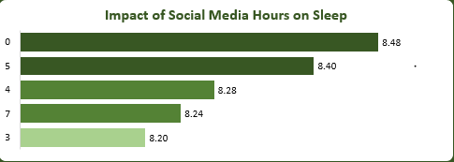

**Observation:**  
 Students with 0 hours of social media use sleep the most (8.48 hrs), while sleep decreases with increasing social media use.

**Recommendation:**  
 Raise awareness about digital wellness and the impact of screen time on sleep. Limit late-night social media use with campus-wide education programs or digital detox initiatives.

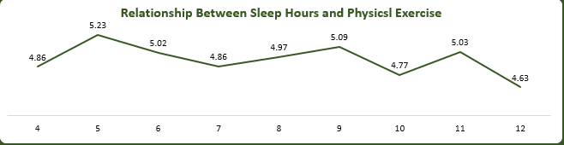

**Observation:** Sleep duration slightly increases with moderate exercise but declines again after excessive physical activity (12+ hrs/week), where average sleep drops to 4.63 hours.

**Recommendation:** Advise moderation in exercise—8–10 hours/week seems optimal—to avoid fatigue or insomnia linked with over-exercising.

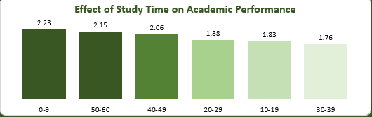

**Observation:** Academic performance peaks at 30–39 hrs/week but declines for students studying over 40 hours, indicating possible burnout or inefficiency.

**Recommendation:** Provide time management and academic strategy workshops to help students get more value out of study time without overworking.

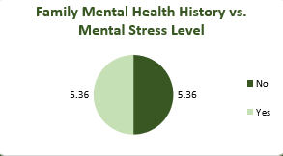

**Observation:** Average stress levels are identical (5.36) for students with or without family history of mental illness.

**Recommendation:** Adopt inclusive mental health support services for all students, as stress seems to be equally experienced regardless of family background.

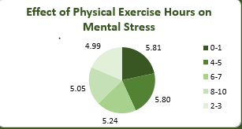

**Observation:** Lowest stress observed at 8–10 hours/week (4.99). Stress remains higher at all other brackets, peaking at 5.81 for 0–1 hour of exercise.

**Recommendation:** Incorporate structured physical fitness programs into the academic week and encourage regular moderate exercise through accessible gym and fitness center hours.

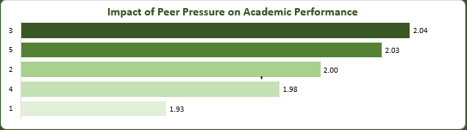

**Observation:** Higher peer pressure levels correlate with lower GPAs. Level 5 peer pressure corresponds to a GPA of 1.86, the lowest recorded.

**Recommendation:** Introduce peer mentoring, counseling, and awareness sessions on managing expectations and healthy competition. Build support networks to diffuse unhealthy academic comparisons.

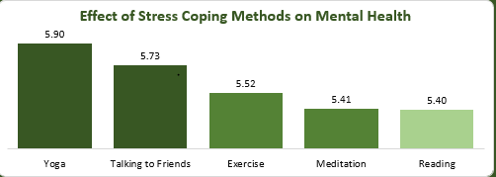

**Observation:** Top performers:

* Yoga (5.00 stress level)
* Talking to friends (5.73)  
   Least effective:
* Reading (5.40)
* Meditation (5.41)

**Recommendation:** Guide students to use proven stress-reducing methods like Yoga and social support. Consider training staff in identifying students relying on less effective coping methods and redirect them to more beneficial alternatives.

* **Dashboard View**: Consolidated overview of metrics for fast insights.  
  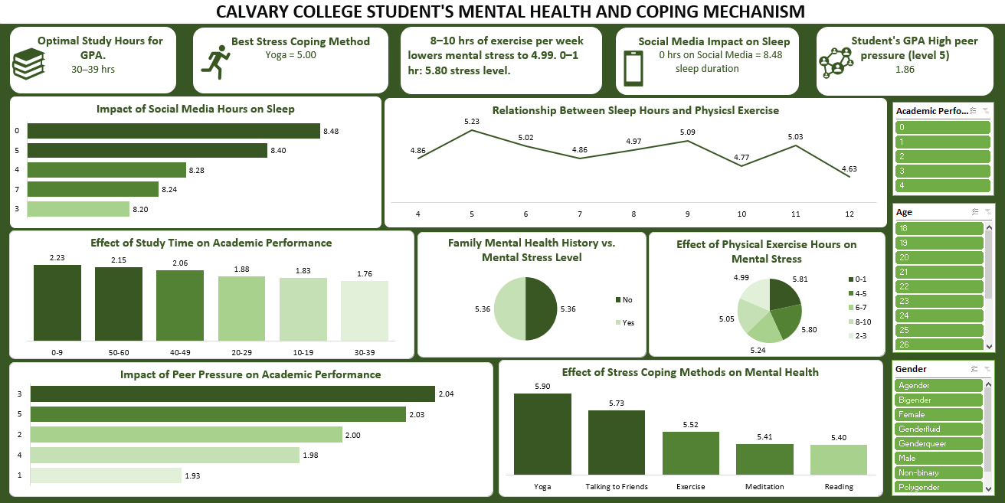

### **Explanation of Visualizations:**

* Charts effectively communicate the impact of habits and behaviors on academic and mental health.
* The line graph shows diminishing returns of sleep after moderate exercise hours.
* The bar chart reveals an optimal study hour range (30–39) before GPA drops.

**9. Recommendations and Observations**

### **Actionable Recommendations:**

1. **Promote Yoga and Group Counseling** Integrate Yoga sessions into wellness programs and offer group therapy or open conversation forums to reduce isolation and peer pressure.
2. **Optimize Academic Support:** Cap recommended study plans around **30–39 hours/week** and provide coaching to improve **study effectiveness**, not just quantity.
3. **Limit Social Media in Dormitories or Libraries:** Implement campus-wide education campaigns on the impact of excessive social media use on **sleep hygiene**.
4. **Exercise Campaigns:** Encourage **8–10 hours of moderate physical activity** weekly, including sports, gym access, or dance/yoga clubs.
5. **Mental Health Monitoring:** Despite similar stress levels between those with/without family mental illness, implement **universal mental health screening**, as all students are vulnerable.

### **Optimizations for Institutions:**

* **Resource Allocation:** More funds should go to programs with high returns—like Yoga classes or peer-led discussion groups.
* **Awareness Initiatives:** Use infographics from the dashboard in flyers and student orientation materials to **raise behavioral awareness**.
* **Early Intervention Tools:** Create Excel-based self-assessment tools for students to log and monitor their weekly study, social media, and stress levels.

### **Unexpected Outcomes:**

* **Equal stress levels** among those with and without mental health history suggest the dominant role of the **college environment** over genetic factors.
* Students with **very high study hours** had **lower GPAs**, indicating the need for better time and stress management training.

## **10. Conclusion**

### **Key Learnings:**

* Mental health is intricately linked to academic performance.
* Physical wellness (exercise, sleep) and social factors (peer pressure, social media) critically influence outcomes.
* Holistic student support programs must consider these dimensions.

### **Limitations:**

* Data limited to one institution
* Self-reported metrics may carry inherent bias
* Lack of temporal depth (e.g., year-over-year trends)

### **Future Research:**

* Conduct longitudinal studies across multiple colleges.
* Investigate how GPA and stress evolve over semesters.
* Study interaction effects between multiple coping strategies.